E U R O P E A N |  |  | 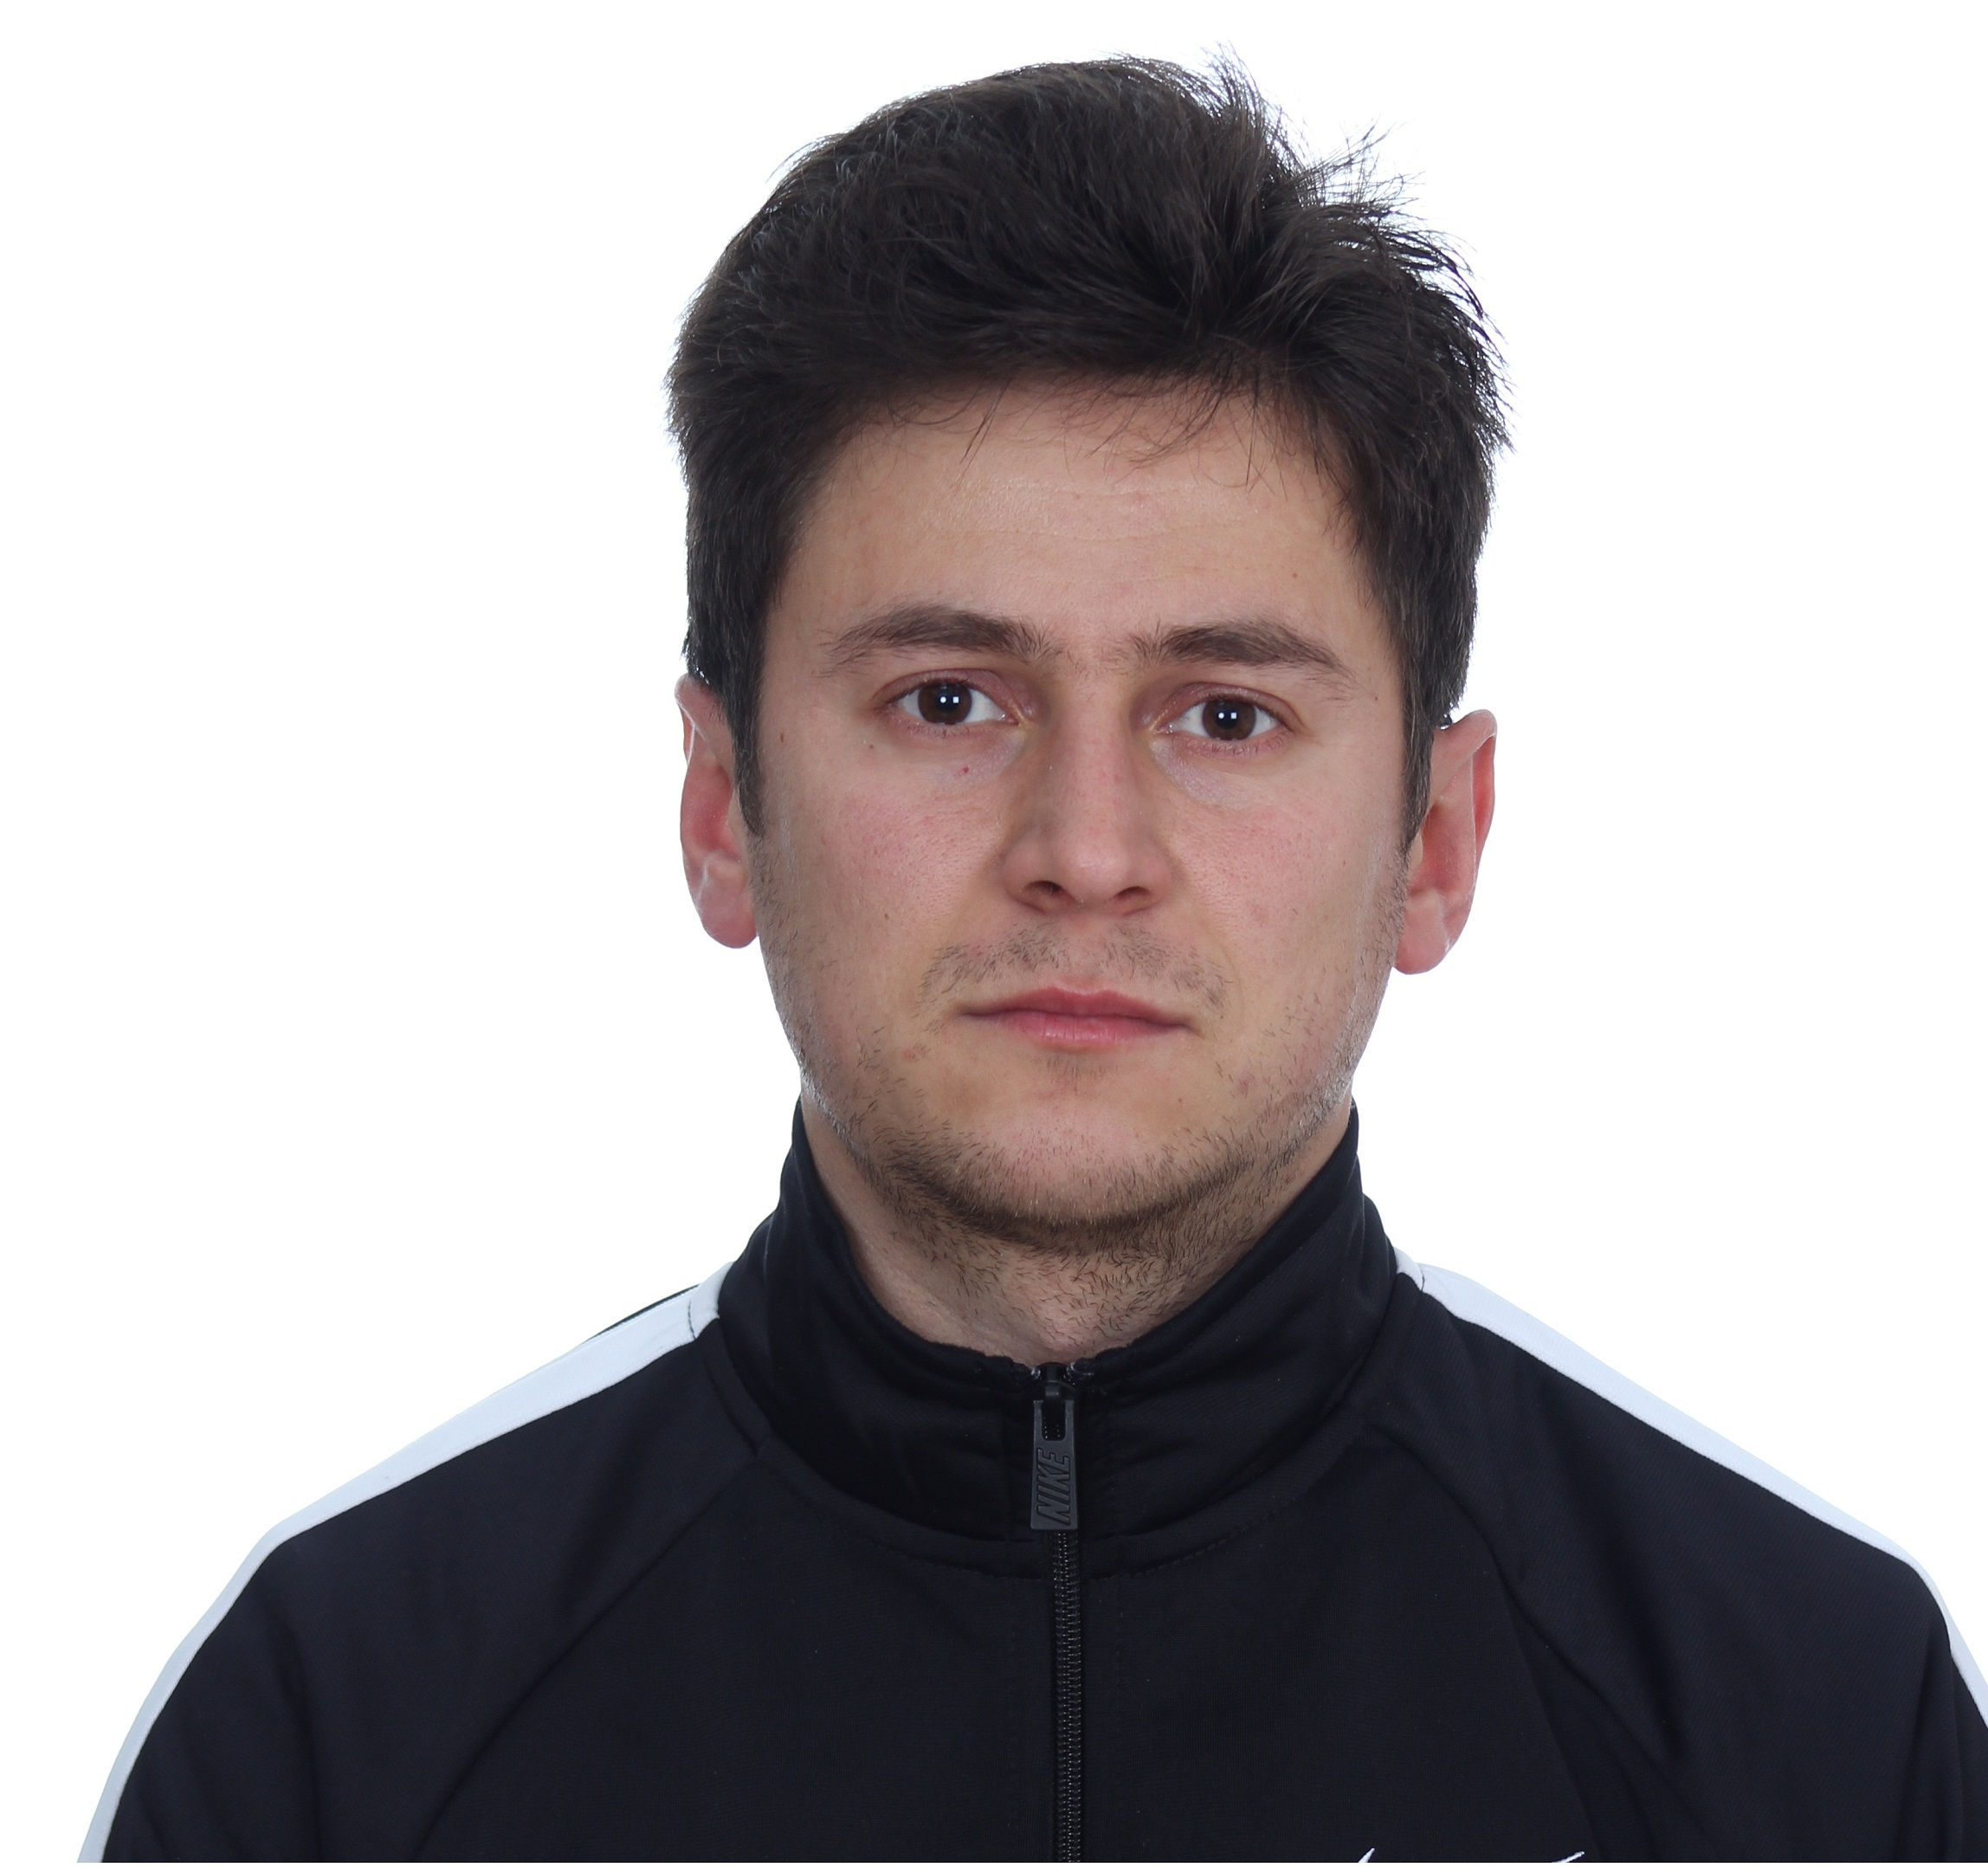
C U R R I C U L U M V I T A E
PERSONAL INFORMATION
Name |  |  | Boban Jakimovski
Address |  |  | 4 July 24 Sveti Nikole, Macedonia
Telephone |  |  | +38978 745 714
Fax
E-mail |  |  | bobanjakimovski@ymail.com
Nationality |  |  | Macedonian
Status |  |  | single
Date of birth |  |  | 18.05.1987
WORK EXPERIENCE
• Dates (from – to) |  |  | 11.2013-04.2015
• Name and address of employer |  |  | ‘’Art Bar’’ D.O.O. plaza Ilinden bb.
• Type of business or sector |  |  | Catering
• Occupation or position held |  |  | Bar Waiter,Bartender
• Main activities and responsibilities |  |  | Serving alcoholic beverages, Set-up bar stations and complement the bar
• Dates (from – to) |  |  | 06.2010 to 10.2011
• Name and address of employer |  |  | “Liquor Store Vinoro“,54 Kliment Ohritski Blvd.1000 Skopje
• Type of business or sector |  |  | Trading Industry
• Occupation or position held |  |  | Seller
• Main activities and responsibilities |  |  | Selling Beverages
EDUCATION AND TRAINING
• Dates (from – to) |  |  | 09.2008 to 06.2012  University “Goce Delcev“ Stip - Faculty of Economics
• Name and type of organisation  providing education and training |  |  | Triple- s (certificate of production planning)
• Principal subjects/occupational  skills covered |  |  | Financial Management,Мonetary Еconomy,Financial Accounting,  Foreign Trade,Analysis of Financial Statements
• Title of qualification awarded  • Level in national classification |  |  | Graduate Economist
(if appropriate)
• Dates (from – to)  • Name and type of organization  providing education and training  • Principal subjects/occupational  skills covered  • Title of qualification awarded |  |  | 01.09.2002-19.06.2006  High School “Demu Kole Nehtenin”-Stip  Electrical skills  Electro technician-electronics
PERSONAL SKILLS
AND COMPETENCES
Acquired in the course of life and career
but not necessarily covered by formal
certificates and diplomas.
MOTHER TONGUE |  |  | Macedonian
OTHER LANGUAGES |  |  | English
Indicate level: excellent, good, basic.
• Reading skills |  |  | excellent
• Writing skills |  |  | excellent
• Verbal skills |  |  | excellent
SOCIAL SKILLS
AND COMPETENCES |  |  | I was in so many situations, that I have no problems with communication with other people.
TECHNICAL SKILLS
AND COMPETENCES
With computers, specific kinds o |  |  | Office, Internet,Pantheon,CFMA( Software for Accounting),EAGLE(Software for electronic schemes)
equipment, machinery, etc.
ARTISTIC SKILLS
AND COMPETENCES
Music, writing, design, etc.
OTHER SKILLS |  |  | loyalty, creativity,positive attitude
AND COMPETENCES
DRIVING LICENCE(S)
ADDITIONAL INFORMATION |  |  | Pas No:
ANNEXES

